**How to disable Windows updates permanently**

**Stage 1**

Run \\ger\ec\proj\ha\perc\ITBuilds\Scripts\PostBuild\DisableUpdates.ps1 on the destination computer,

*NOTICE- make sure you run PowerShell as **Administrator** and run the following command before running the script **Set-ExecutionPolicy Bypass** and confirm with “Y”

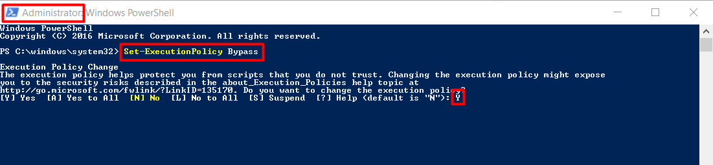

**Stage 2**

Open GPO Editor by pressing “**Windows + R**” and type “**gpedit.msc**”

Navigate to Computer **Configuration > Administrative Tools > Windows Components > Windows Update**

Double click on “**Configure Automatic Updates**” and set to **Disabled**

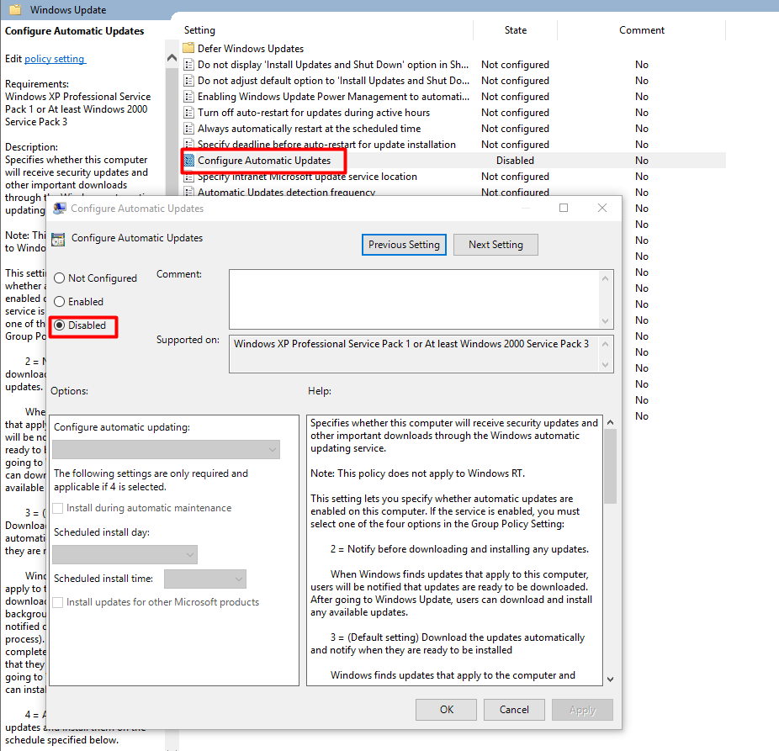

Double click on “**Remove access to use all Windows Update features**” and set to **Enabled**

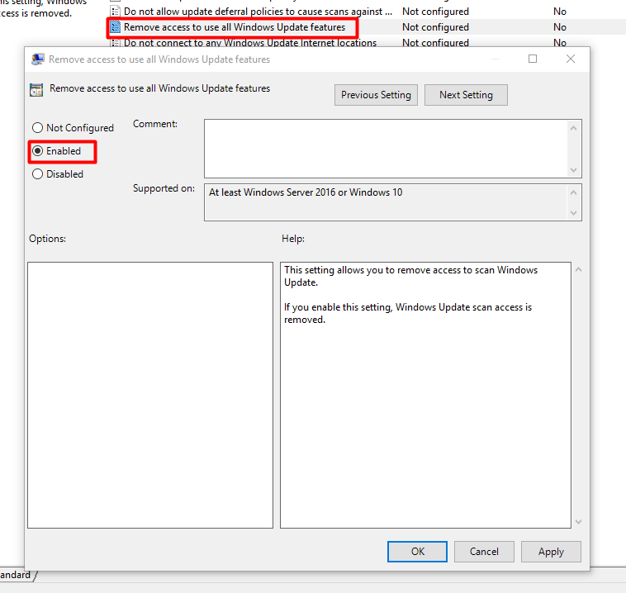

Restart the computer and you done ☺

Sahar Tal

11586861